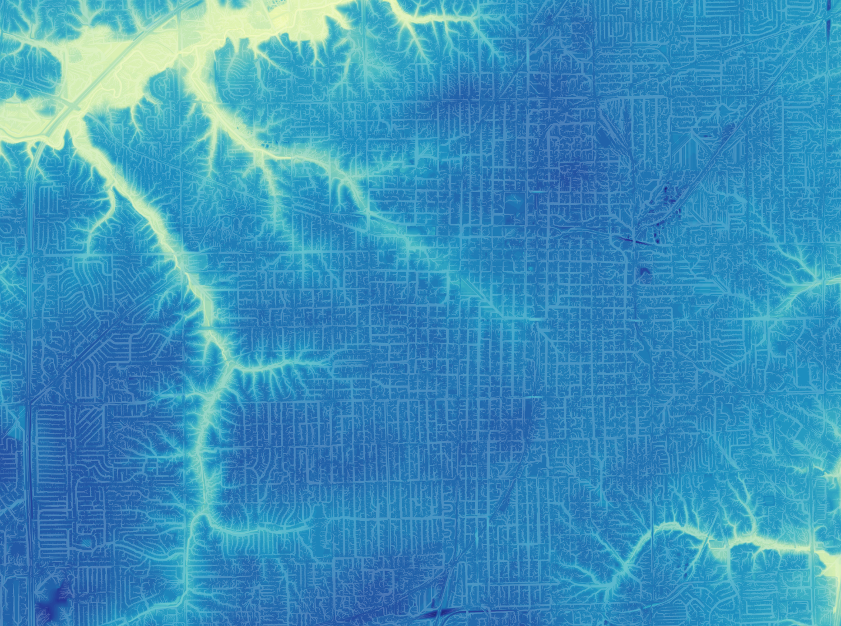

**WATERSHED**

**Watershed is a collection of hydrology automation scripts**

*Using high resolution terrain models, Watershed creates high definition contouring and streaming of the City. Comprehensive watershed datasets are a useful tool for stormwater mapping and analysis, a historically poorly documented part of the City’s sewer stormwater network.*

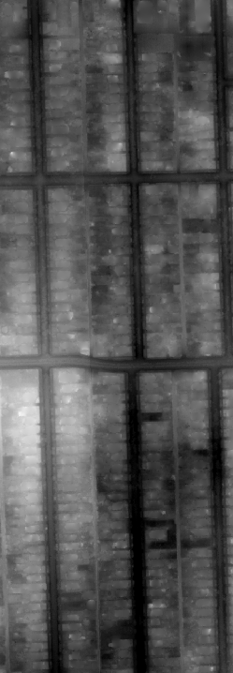**About the source**

The [**Illinois Height Modernization Program**](https://clearinghouse.isgs.illinois.edu/data/elevation/illinois-height-modernization-ilhmp) is a publically funded program that aims to modernize elevation data within Illinois. Historically, elevation models had been based on 5- or 10-foot contour data. The updated resolution, created using LiDAR, is 2 feet to 6 inches. The resultant derivative data is beautifully rich and informative. The ILHMP provides datasets organized by county. Sangamon County has a compressed DEM dataset with a resolution of 2 feet totaling 48.8GB that can be used to create derivatives – contour lines, contour polygons, and stream ordering – among others.

**Overflowing with data**

High definition data poses its own issues. The DTM contained inside the compressed archive is 34.4GB in the form of a countywide DTM layer. In order to convert this DTM into contours and streams it would need to be processed multiple times. To ease this process the DTM should be clipped to roughly the city’s extent and split into cells. The PLSS Quarter Sections layer in the Cadastral dataset neatly fills both requirements as it is already separated into polygons and almost perfectly encapsulates all land with City-owned sewer and stormwater networks.

**Raw DTM**

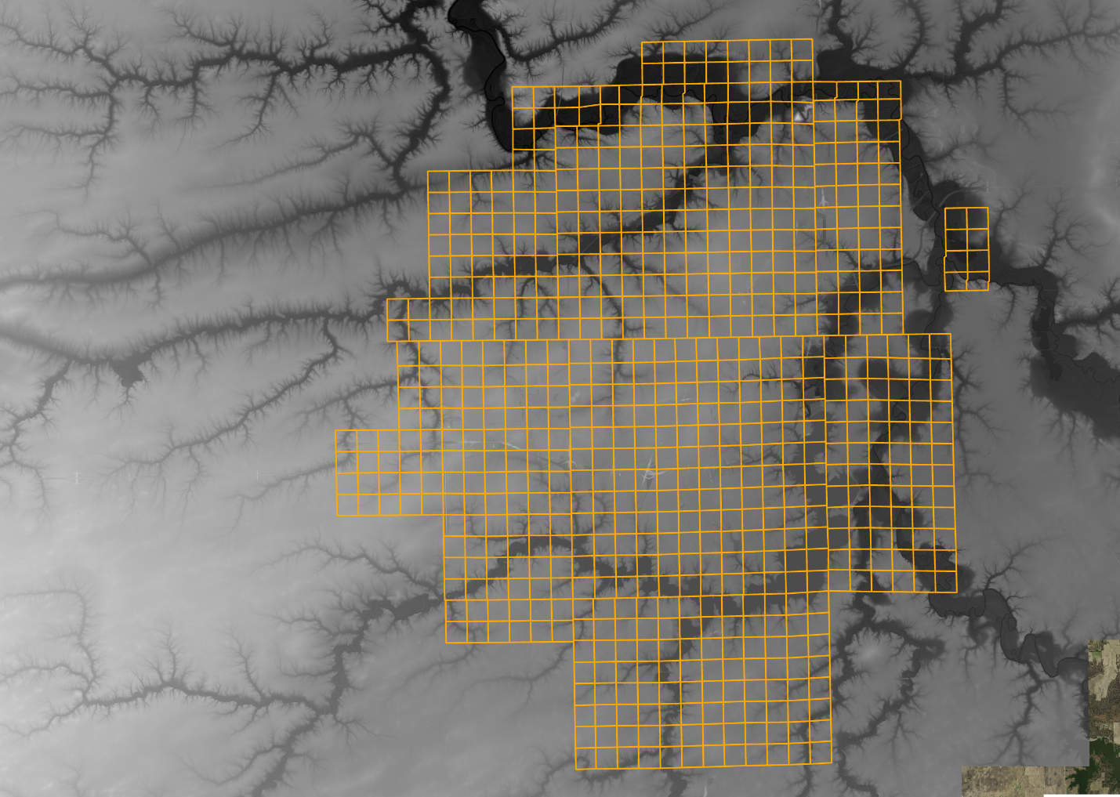

**DTM to be clipped**

**393 Quarter Sections**

Using the first script, **Extent.py**, the full-size DTM raster is clipped and split. The split raster is 2.43GB in size with 393 individual cells. From here processing the raster is a lot quicker. Separating this large dataset into discrete cells also allows us to later name each cell after the PLSS Quarter Section sewer map field. Additionally, should the script catch an error and exit, we can resume a function at the last completed cell instead of restarting the entire DTM.

**Contouring: Polygons and Lines**

Contouring on its own is a relatively simple process. The split DTM can be used directly with the Contour tool in the Spatial Analysis toolbox. From there it can be further processed. **Contours.py** contains the entire contouring process.

**Contour Lines**

The first goal is to convert the DTM into isometric contour lines. Each line will represent a 1 foot change in elevation. Of particular use for the case of hydrology is the steepness of slopes, represented by the distance between each contour line. This will help with locating local low spots such as swales or ditches.

An unfortunate side effect of using high resolution data is that it produces a plethora of junk data. The raw contour has hundreds of thousands of loops with short lengths that don’t necessarily provide useful information. Additionally, the contour lines are unnecessarily detailed with small scale winding and bending. To clean it up, the script first selects all lines longer than 350ft. It then employs the Simplify Line tool in the Cartography toolbox using the selected contours as the input.

The result of contour simplification is a collection of jagged contours that are sufficient for hydrology analysis. The next step, from a utilitarian standpoint, doesn’t provide much benefit for analysis; it however improves the aesthetics of the contours. The output of the Simplify Line tool is used as the input for Smooth Line tool. The result then becomes smooth, curving lines with minimal clutter.

**Contour Polygons**

The second goal is a polygonal representation of contours. The data is nearly identical to the DTM. However, polygons are an easily filterable, selectable format for discrete contours. They’re also conveniently placed in a file geodatabase.

**Renaming**

Thus far, the contours have not yet been assigned a name, aside from a placeholder such as “contours_lines_000”. To make it easier to find specific cells, they’re renamed using a prefix and the quarter section’s name. “CL_1414GH” and “CP_1434CD” are examples for lines and polygons, respectively.

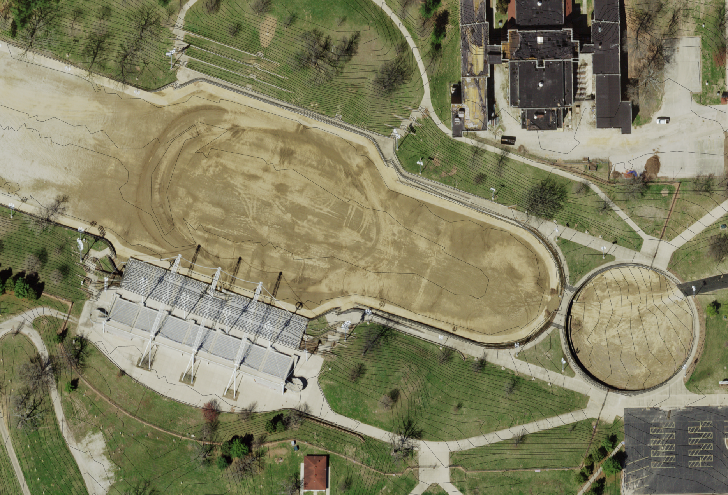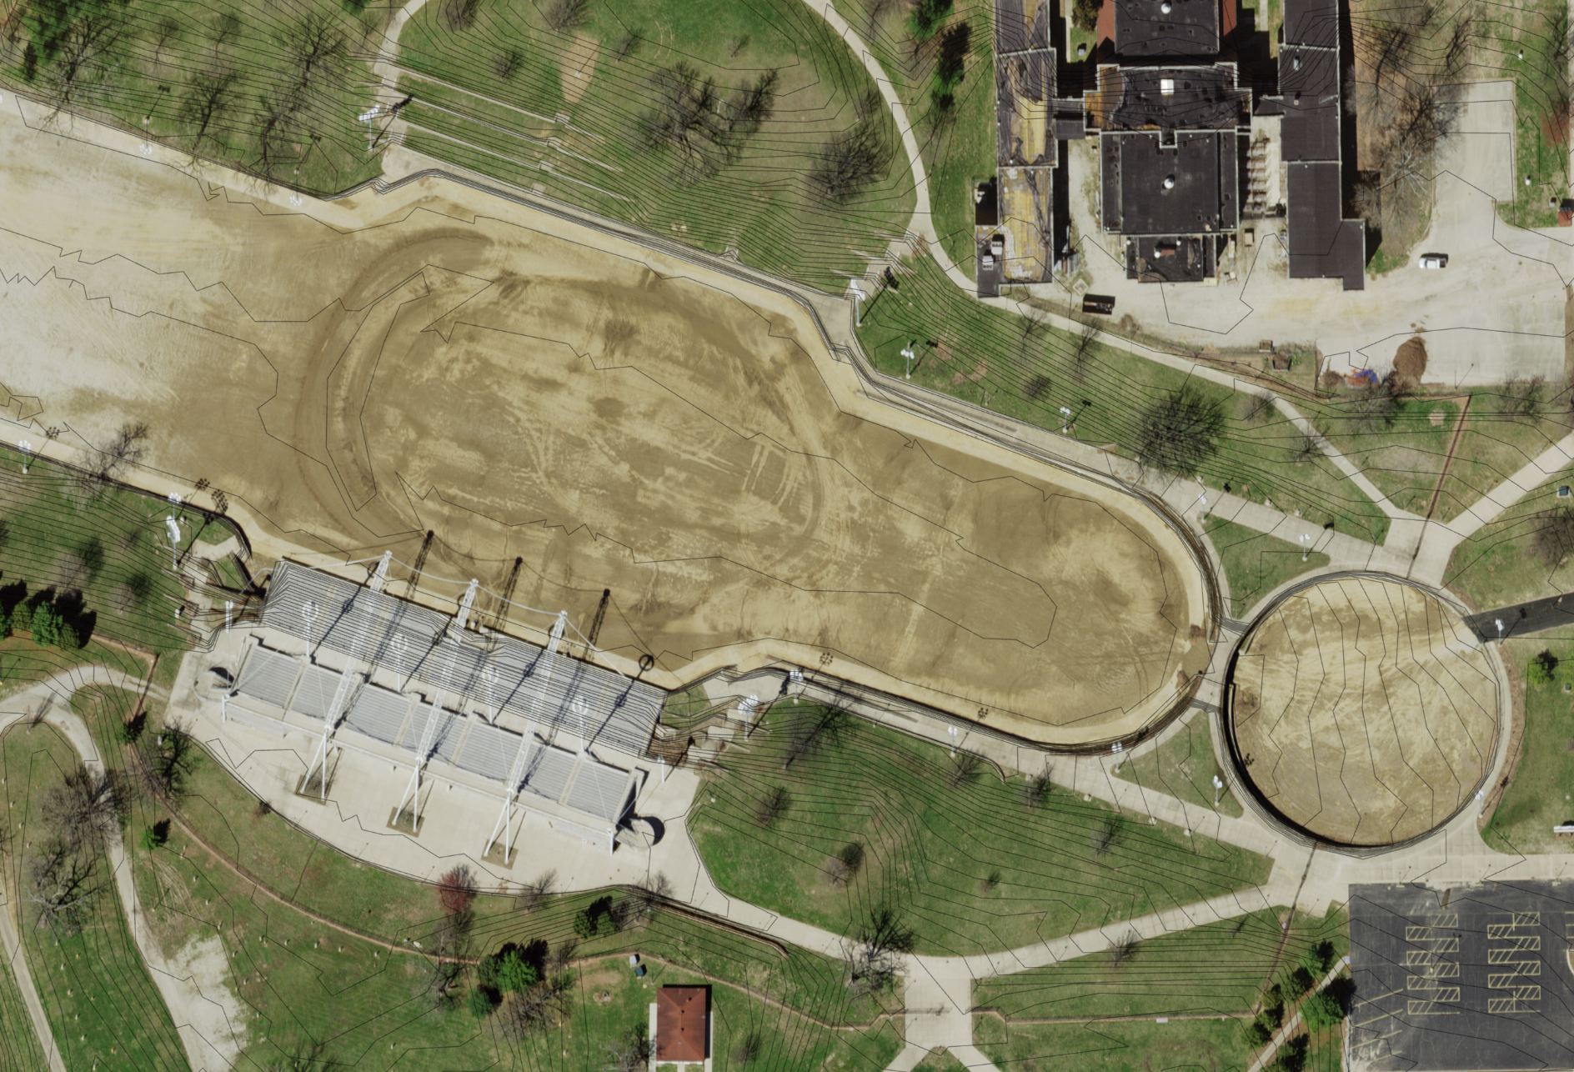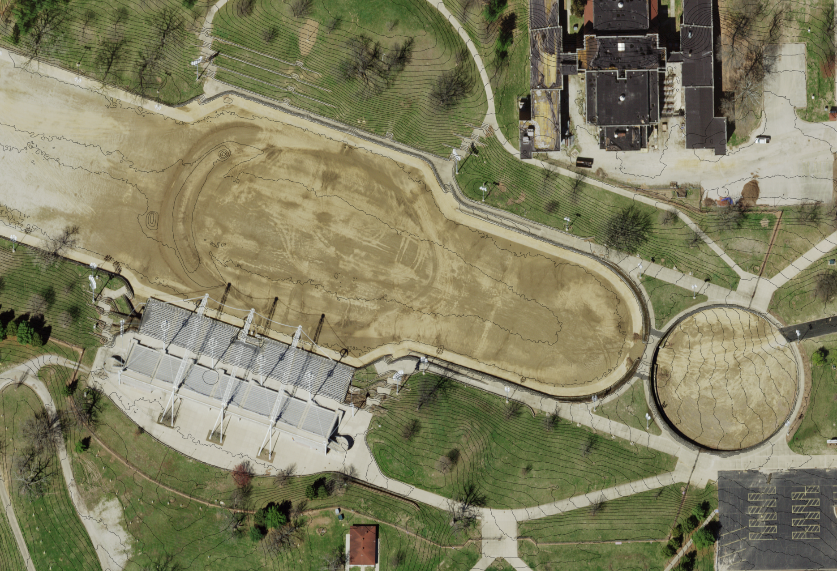

**Contours**

**Contours (Smoothed)**

**Contours (Simplified)**

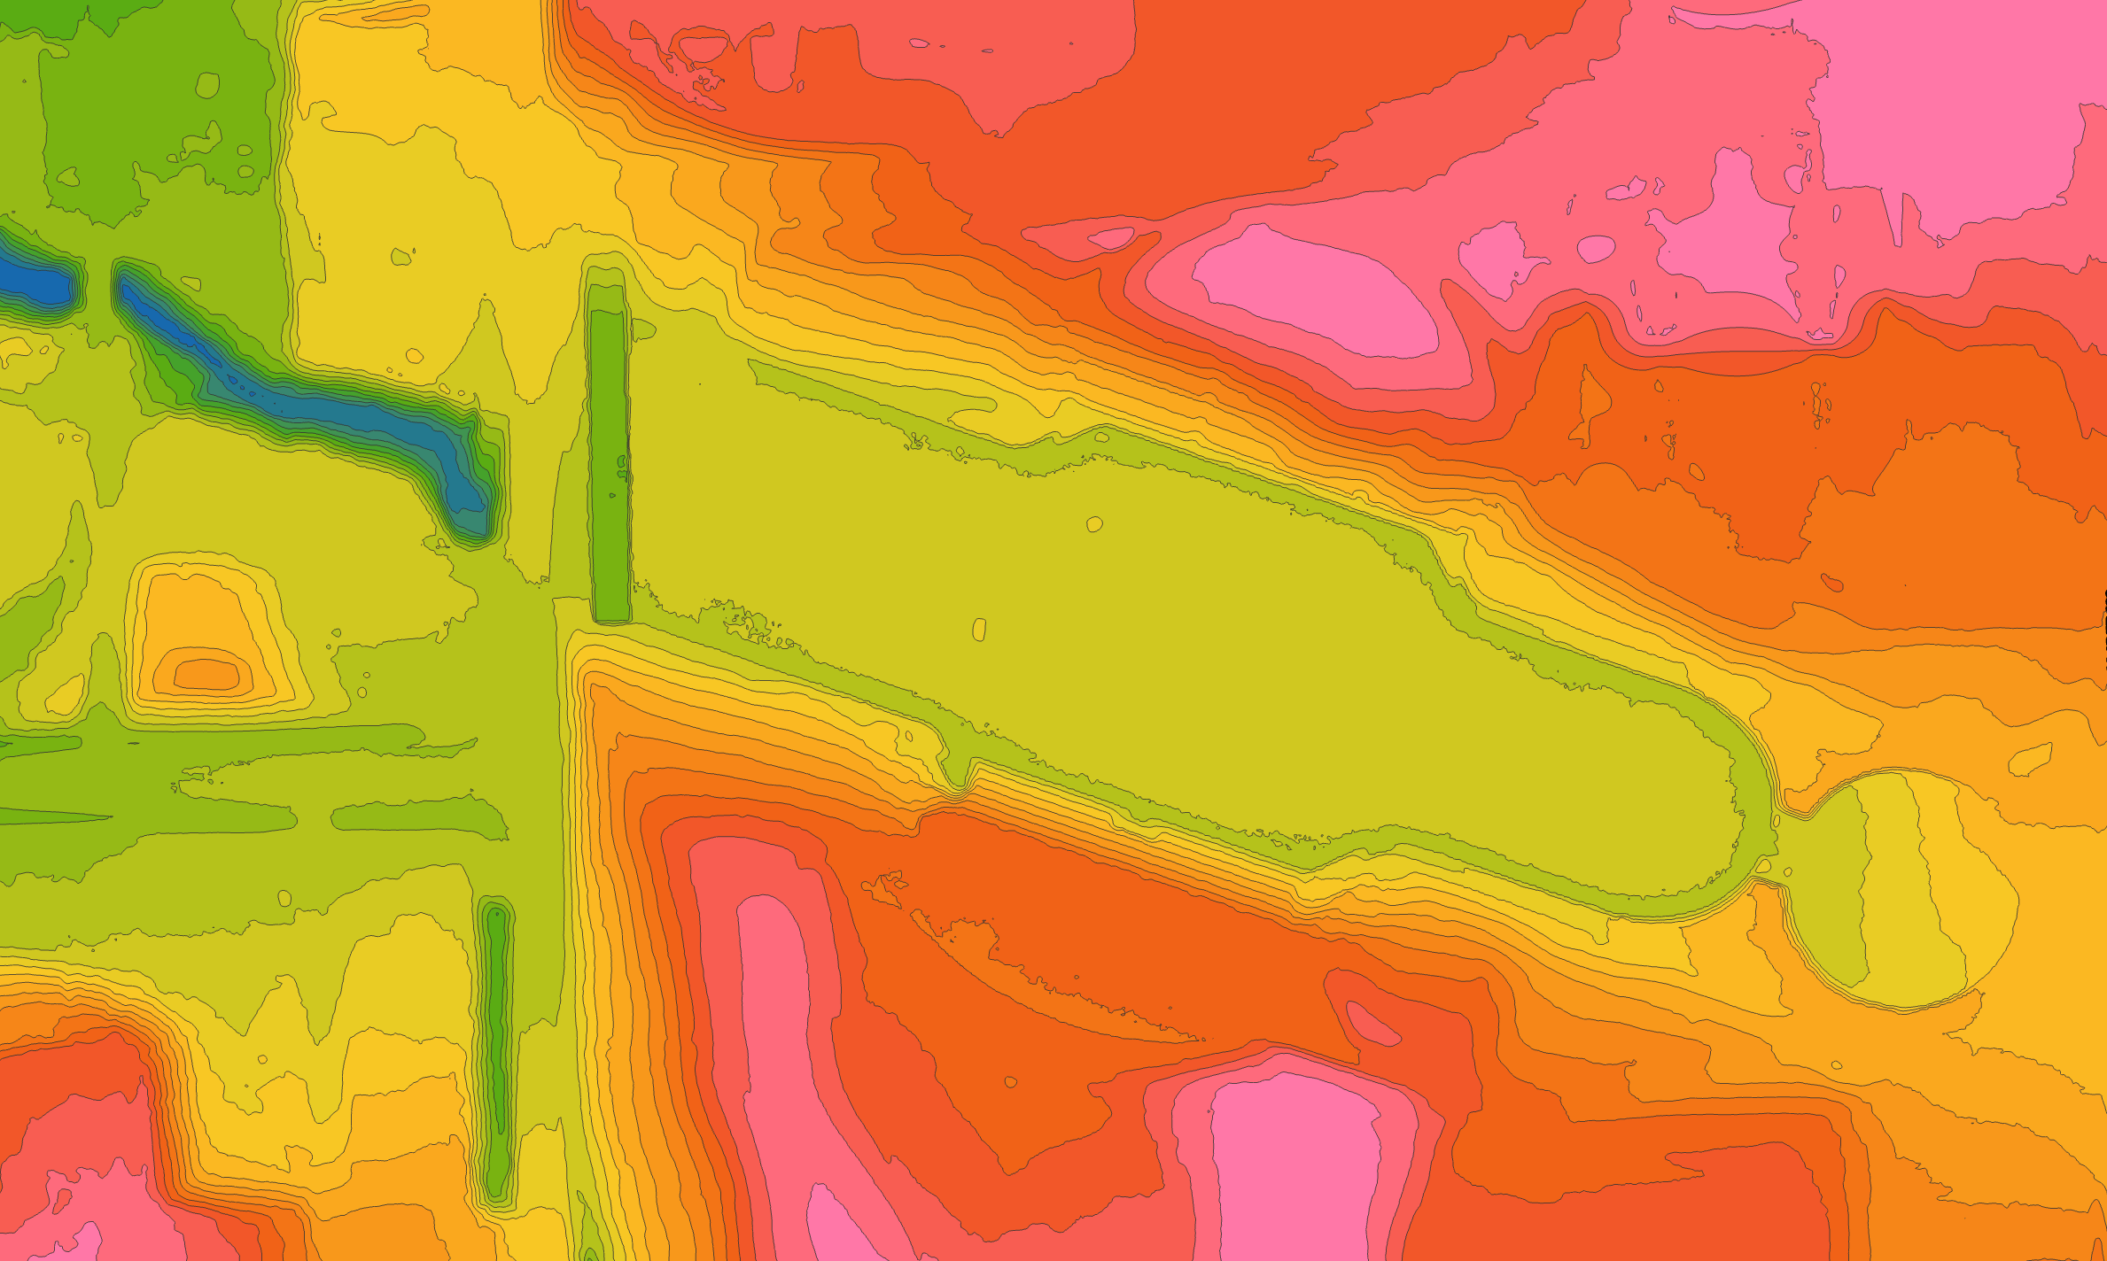

**Contours (Polygons)**

**Examples**

Above are examples of the intermediate data created by the script. It’s evident that there is too much detail in the raw contour line layers. After processing, the lines become less complex. This declutters the map while also decreasing the number of vertices. The curve smoothing currently applied is barely noticeable at this zoom scale but becomes more apparent as the scale decreases. Finally, slight modifications to the script can be made to increase or decrease the simplification and smoothing process.

**Stream Ordering**

Stream ordering is the mathematical method of assigning a numeric order to links in a stream network. Streams with no tributaries are assigned a value of 1; downstream links are assigned an increasing value based on the number of incoming tributaries. There are two methods of assigning that value.

1. The **Strahler method** increases the stream order value when two streams of equal order intersect – orders of 2 and 2 intersecting would result in a value of 3.
2. For the **Shreve method**, the order values are additive – orders of 2 and 3 intersecting would result in a value of 5.

In the hydrological sense, stream ordering is useful to determine the direction of the flow of water as well as the magnitude of incoming flow. The entire process is contained in **Streams.py**.

**DTM to Stream Ordering**

In order to create stream ordered features from a DTM, several functions need to be run before and after stream ordering. Because of this, the stream ordering process creates a large amount of intermediate data. All of the work is done in raster format, converted in a feature class inside a dataset, then split by PLSS Quarter Sections. The order of operations is as follows:

1. **Fill** cleans up small imperfections in the data, this function fills in small sinks. A sink is a local low spot of less than *z* feet difference in elevation from the surrounding cells. By default, *z* is any value.
2. 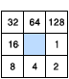**Flow Direction** calculates a flow direction for each cell based on the surrounding cells’ elevations. The direction can be in the form of D8, MFD, or DINF. All of these produce a numerical value describing the flow direction. A future process requires a D8 direction raster. D8’s values are 1-255 with the above diagram showing the corresponding numerical value and direction. (For example, a 1 value means the flow is to the east.)
3. **Stream Ordering** is the actual stream ordering process as explained above.
4. **Condition** filters out data based on a given condition. In order to declutter the final layers, Condition removes all streams with a value less than 5. These are too small and too numerous to be useful. This value can be adjusted.
5. **Stream to Feature** converts a given stream raster into a feature class. This requires a D8 direction raster (output of Flow Direction) and a stream raster (output of Condition).
6. **Split and Rename** splits the output of Stream to Feature by each cell in PLSS Quarter Sections then assigns it a name based on the quarter section’s “SEWMAP” field.

**Example**

Below is the final product. A higher stream order appears as a thicker line. It’s evident that most of the streams here flow from neighborhood streets to Outer Park then to the west. Analyzing the other layers also shows that Outer Park is a creek flowing west.

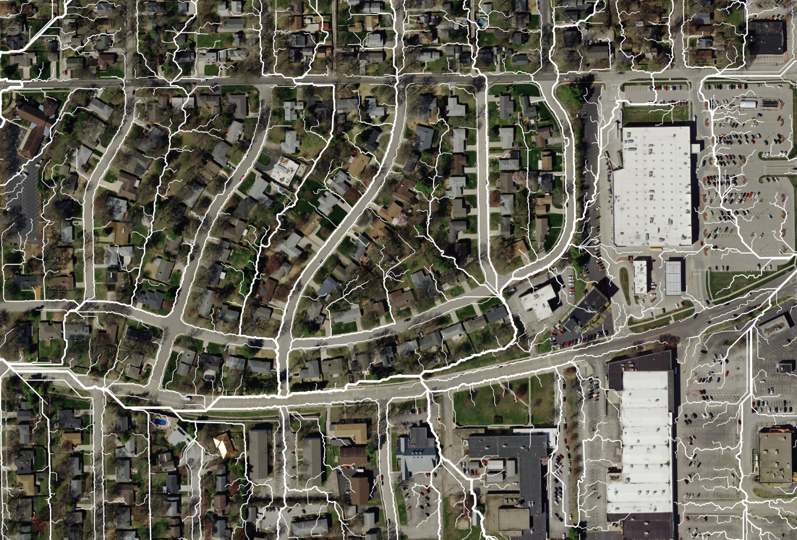

**Streams**

**Finalization, Python, and the Real World Use Cases**

Both contouring and stream ordering output to the final database, Watershed.gdb. This database contains three datasets: ContoursLines, ContoursPolygons, and Streams. Each of these contain 393 cells. The last script to run, **Merge.py,** also takes all of these cells and merges them back into one citywide feature; this is output to the relevant dataset with “Merged” affixed. The purpose of this structure is to provide a searchable collection of hydrology outputs while also giving the option to view the entire city at once. This should hopefully make navigating 1182 separate feature classes a quick and easy task.

**About the Python**

The key engines to the script are the custom functions **FeatureProcessor**, **RasterProcessor**, **SplitRename**, and **RenameMove**.

The two processor functions have a dictionary of functions to run, accessed using the **function_key** parameter. The processor is tasked with looping through all features or rasters within the input dataset, running the function on the selected **input_dataset/input_folder**, and outputting to the **output_dataset/output_folder**. The function keeps track of the current iteration value and uses it as a suffix for the output name (e.g. contours_lines_**005**). This iteration is able to be resumed at any point with the **start_point** parameter should the script fail. This is very likely to occur since each function could take several hours to run. RasterProcessor has a **raster_format** parameter. Some raster datasets output in folders or TIFs; this parameter allows you to switch the input type between those two. FeatureProcessor has a **feature** Boolean parameter; you can switch this in case your input is a raster. All of this combined means that any expansion would require minimal work – simply adding the desired function to the dictionary. The script would handle the rest.

**RenameMove** simply loops through the input dataset, renames it after a containing quarter section, and moves it into its final location on Watershed.gdb. This has the same parameters as the processors including **start_point**.

**Watershed in Action**

Below is an example of one of the first uses of this data. One image shows the aerial view of a drainage area directly south of the Montvale Schnuck’s. The trees and grass in this area obstruct visibility, making it difficult to tell what is happening.

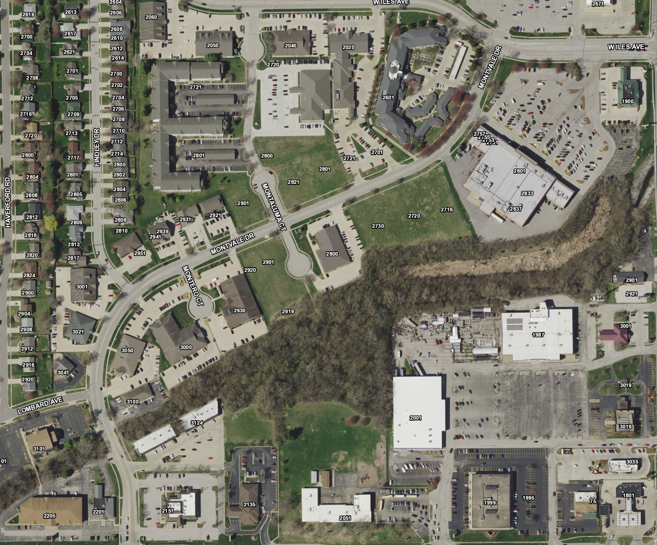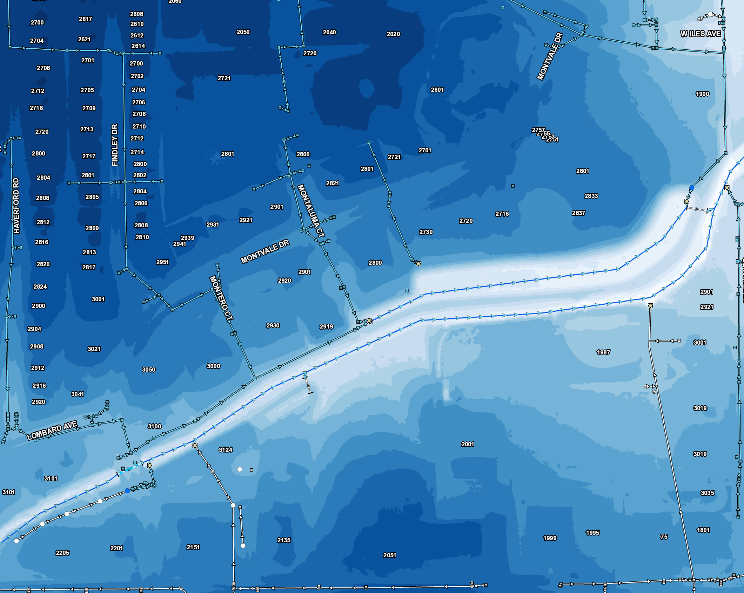 With the assistance of contour polygons, it becomes immediately evident that this is a combination of a creek and a detention basin. These two are separated by a barrier and eventually connect via a culvert to the northeast. It is also possible to get a general location of the many discharge points.

With all of these datasets, indirect analysis and mapping of the stormwater network will be much more efficient.